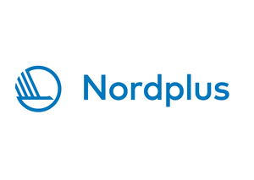

APPLICATION FORM

participation in “Nordic-Baltic Network in Corporate and International Finance” teachers’ mobility program

- Teacher name, surname:
- Home institution, Country
- Position:
- E-mail:
- Phone:
- Host institution, Country
- Planned period and duration of Exchange

- Specify the expected mobility programs:
(The minimum duration of the teacher exchange is 8 teaching/working hours)

- Other activities

Place and date:_________________________

Signature:_____________________________

Please send your application by e-mail to ramona.rupeika-apoga@lu.lv.

